Large criterion D questions usually look something like this:

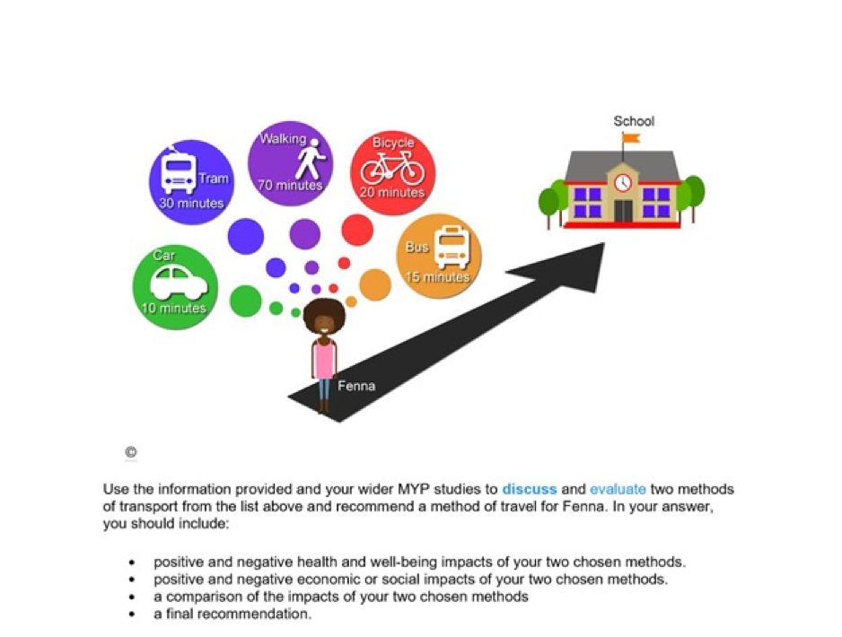

NOTES:
- Each of the bullet points in the question must be at least one paragraph in your answer
- Read the question carefully. Does it ask for impact or impacts/ advantage or advantages. This also indicates the amount of paragraphs that you should have.
- If there are facts in the sources, use these facts in your answer. This is a simple way of changing you answer from a 1 mark "answer is stated" to a 2 mark "answer is discussed" or 3 mark "answer is evaluated".
- You only have one minute per mark in the exam so work diligently to get the marks. The marking scheme is very predictable. If you are really stuck for time then you can write in bullet points but make sure that they are still divided into topics. Use sub-headings if you want.
- If they are for a final statement of conclusion then it will be worth at least 1 mark. Refer to the points that you have made earlier in the essay and make a final suggestion/ concluding remark.

SUGGESTED ESSAY PLAN:
- Introductory paragraph describing the problem and possible solutions
- Explain 1 positive health/ wellbeing impact for a bike
- Explain 1 negative health/ wellbeing impact for a bike
- Explain 1 positive health/ wellbeing for a bus
- Explain 1 negative health/wellbeing for a bus
- Explain 1 positive economic impact for a bike
- Explain 1 negative economic impact for a bike
- Explain 1 positive economic impact for a bus
- Explain 1 negative economic impact for a bus
- Compare bike and bus health impacts
- Compare bike and bus economic impacts
- Using information from the points above, write a concluding statement, recommending one method and give a justification to explain why.

PARAGRAPHS:
A good structure for your paragraphs is something like this.
- State your point using the words ADVANTAGE/ DISADVANTAGE/ SOCIAL IMPACT/ ECONOMIC IMPACT etc.
- Give information from the source (or relevant factual science if there is no source information)
- Explain the point.

One positive health impact of cycling to school is that it will increase Feena's fitness. The cycle to school each morning and home in the afternoon will take her approximately forty minutes. This exercise will have tremendous benefits for Feena's ability to play sports and leisure activities as well as keeping her heart and body in good health.

MARKING SCHEME:
Here is the marking scheme from the IB for the question above. Most of the time it is graded on a rubric like this.

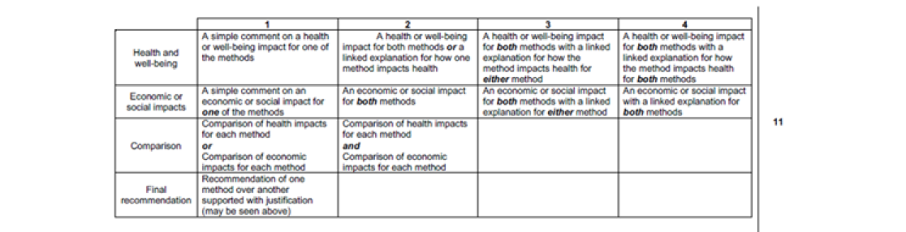
Very predictable!

Here is another marking scheme from a different question. As you can see, it is very similar.
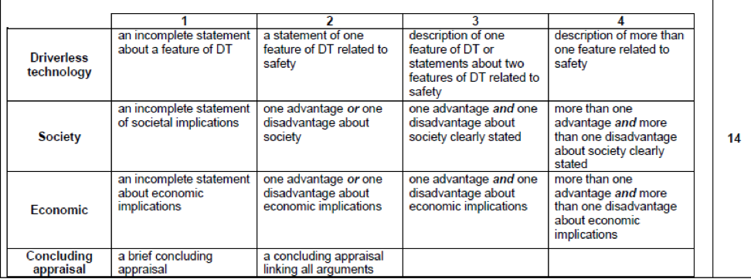

Note:
- statements get 1 or 2 marks whereas descriptions get 3 or 4
- Concluding statements get 1 mark but ones that summarise and weigh up your points get 2.

Tip: Use the "DEEC" pneumonic to remember the steps.
- Describe: Describe the problem / scenario and solution or solutions. Include key facts and information that has been provided to you in the scenario.
- Explain: Explain the solution or solutions to the problem, giving reasons why this solution was suitable and expanding on the further impacts of the solution or solutions.
- Evaluate: Evaluate in relation to each of the factors given, giving multiple advantages and disadvantages for both.
- Conclusion: Write your final appraisal, giving a recommendation by summarizing and comparing the advantages and disadvantages. Justify this recommendation (ie. explain why the advantages outweigh the disadvantages or vice versa, offer up potential solutions to the disadvantages that may explain why the advantages are outweighing the disadvantages).

Below is a L7-8 Sample Answer including notes on how that answer was constructed.

Notes:

Note: Some questions may require a larger or more in depth description of the problem and explanation of the solution in the introductory paragraph, but in this question, the instructions did not state anything about this. The first bullet point relates to the health impacts of your two chosen methods, so no need to waste time on this section in this case. Read the bullet points under the main heading of the question carefully for guidance about what needs to be included.

Note: Total of 8 advantages/disadvantages required - 4 advantages (2 for each method) and 4 disadvantages (2 for each method). If you are not comparing two options, but instead evaluating a single thing (eg. use of self driving cars to reduce traffic accidents), you must still include 8 total advantages disadvantages. In such a case you would most likely be asked to evaluate the subject in question in relation to two different factors, so give 2 advantages and 2 disadvantages in relation to each factor in this case.

Keep these brief, just enough to clearly state the advantage/disadvantage and give a linked explanation. Remember, explain means you should be using words like, "because", "therefore", etc. In other words, you are explaining the "why" behind your statement.

Your conclusion should link as many of your arguments together in order to compare and contrast them. Use words like, "comparing", "in comparison with", "weighing up" etc. to make this clear to the reader.

It is a good idea to give solutions to potential negative impacts of the option you are promoting. This is a good way to justify your recommendation.

Sample L7-8 Answer:

Fenna must decide which mode of transport to take to school. In this essay, the bike and bus options will be evaluated.

A positive health impact of cycling is that it will improve her overall health. Exercise which increases heart rate is good for cardiovascular fitness and improves heart health as well as overall fitness and wellbeing.

A negative health impact for cycling would be that in order to cycle she will have to get up earlier, because it takes longer to cycle compared with the bus and therefore may have less sleep. Sleep is very important for both physical and mental health and wellbeing so any lack of sleep will negatively impact Fenna's health.

A positive health impact of the bus is that it is less dangerous than other modes of transport because buses travel at lower speeds generally and because of their large size are more able to withstand accidents without injury to passengers provided seatbelts are worn.

A negative health impact for the bus is that in close proximity to others it is easier for transmissible diseases to spread such as viruses or bacterial infections. Therefore using the bus puts Fenna at higher risk of catching a disease.

An economic disadvantage of the bus is that Fenna has to pay for a bus fee. Bus fees can often be expensive and put an added economic pressure on Fenna and her parents.

An economic advantage of the bus is that the cost of the bus may be spaced out over the entire year so if the price is paid for each term then there is no need for an upfront lump sum payment. This will help Fenna's parents with managing their finances.

An economic advantage for the bike is that there are no fuel costs for cycling a bike and no fees are required. This means that Fenna and her parents can spend her money for other things.

An economic disadvantage for the bike is that it has a large up front cost and may have large maintenance fees throughout the year, meaning that Fenna will need to ensure that these costs can be met. These costs may also come at an unexpected time if something breaks.

In conclusion, comparing the costs the bike and bus may have similar costs overall but the bike has a higher upfront cost whereas the bus costs can be spread out over time. However, if the bike could be financed with a loan or credit card, the cost could be distributed over a longer time. Comparing the health impacts, the benefits to Fenna's fitness and cardiovascular health outweigh the positive safety advantages of travelling by bus and also taking into account the negative possibility of her catching a disease on the bus. As long as she is careful on the road and wears the correct safety gear she can minimize her risk of injury from taking the bike. Therefore, overall the bike is a better option for Fenna provided she is careful on the road and takes good care of her bike to prevent damages or breakages which might add to the cost.

